**Case Study: Data Scientist role - Nanoprecise**

**Problem:** To predict the remaining life of a bearing in industrial assets such as pumps, compressors, gearbox etc. Please have a look at the supporting document.

Please read the Readme Document here and refer to the 2nd Test & the research paper:

<https://www.dropbox.com/sh/l0s38bee89wflbx/AAA-Ua4G4YKsjR2UNEuPj7uIa?dl=0>

Here is the dataset:

<https://www.dropbox.com/sh/475lcl9j3s9tfum/AAD45VnnHgxdaIu-qv6AAwp1a?dl=0>

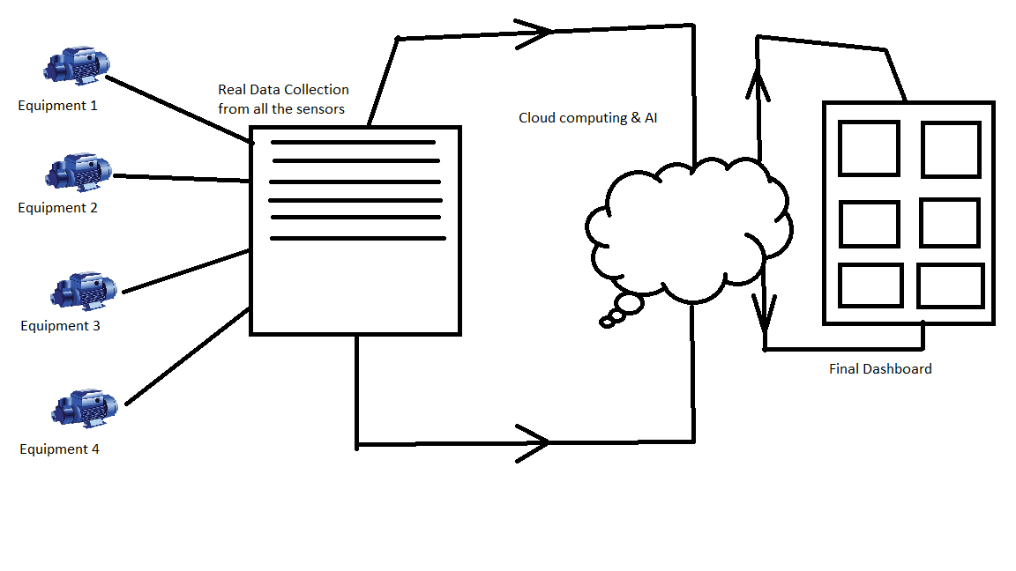

**Deliverable:**

* A graph showing RMS & Kurtosis
* Weibull Hazard Rate & Parameter Estimates (shape & scale parameter)
* Results of training & validation set (as shown in the reference research paper)
* Output performance of test set (as shown in the reference research paper)
* Training & Validation error of the proposed model (as shown in the reference research paper)
* An idea for multi sensor fusion to actually predict the remaining useful of the rotating equipment as a whole